Issues of Post Disaster Residential Relocation to High Land Areas: The Case of Ogatsu District, Ishinomaki City, after the Great East Japan Earthquake in 2011

ELIZABETH MALY1, AKIRA MIYASADA2

1International Research Institute of Disaster Science, Tohoku University, Address,  
Sendai, State ZIP/Zone, Japan  
maly@irides.tohoku.ac.jp

2 NPO Machi-Communication/ Ishinomaki Senshu University (Fukko University) Ishinomaki, Japan   
m-comi@bj.wakwak.com

After the Great East Japan Earthquake, disaster recovery planning is taking place at the local town level in coastal towns throughout the Tohoku area. In many of these towns, disaster recovery planning is taking the form of relocation of residential areas to high land areas. This paper considers the impacts of residential relocation to high land areas though looking at the example of Ogatsu, a fishing village in the south of Miyagi Prefecture. Whereas relocation to high land area is intended to protect residents from the future impact of disaster, the planning process and implementation of relocation has the danger to negative impact the lives of the residents. Along with the choice of relocation, the time needed contributes to a continuing outflow of residents, which threatens both the life recovery of residents as well as the long-term sustainability of the town.

*Keywords*: disaster recovery; relocation; Great East Japan Earthquake

# Introduction

## The Great East Japan Earthquake and Tsunami in Tohoku, Japan

On 2:45 pm, March 11, 2011, the magnitude 9.0 Great East Japan Earthquake struck off the coast of northeast Japan. The resulting tsunami devastated 500 km of coastline, killed more than 18,000 people, and damaged 1,000,000 buildings. The GEJE was a complex, mega disaster affecting a vast and varied area spanning multiple prefectures, cities, towns, and villages, with various geographical, historical, socio-economic, and political contexts. Geographically, the disaster-stricken area includes the Sendai Plain, a wide flat area that stretches from Sendai City in Miyagi Prefecture. To the north, the Sanriku Coast is a rias-type jagged coastline includes the northern part of Miyagi’s coast along with coastal Iwate Prefecture. The Sanriku Coast is dotted with fishing villages that prospered from fishing industry, and the rugged natural beauty of the region makes it a popular tourist destination. In the Sanriku coastal area, tsunamis have been re-occurring every 30-40 years, which is also the case for the Ogatsu area.

## Local Context of Recovery Planning after the GEJE

In Japan, each municipal government is responsible for creating a recovery plan for their town after the GEJE. In small Tohoku coastal towns, the number of local government officials with planning knowledge was limited. Combined with the fact that many officials died in the tsunami, even with the support of government staff sent from other prefectures, human resource capacity for recovery planning was limited. The Japanese national government provides funding for disaster recovery and reconstruction projects, and after the GEJE, the national government created a menu for 40 types of recovery reconstruction projects that will be funded by the national recovery budget. Municipalities can chose from this menu of projects, which include collective relocation, land raising, land readjustment, etc.

With the desire to make visible progress with relocation planning, many local government staff, community leaders, and residents involved in the planning process felt the pressure to decide on their recovery plan direction. With the knowledge that the national government will provide the budget for specific relocation projects, there was also a pervasive tendency throughout the disaster-affected areas to place the emphasis on quickly selecting one of the well-known projects from the national governments’ menu, secure in the knowledge that they could received government funding to carry it out. Officially, the community recovery planning process requires community agreement based on consensus building. However, in actuality, the perceived time pressure and expediency of choosing project types with secured and guaranteed funding led to a process where the often the ultimate goal (a specific pre-determined recovery project) was set, and then the consensus-building or other citizen involvement processes were carried out to get the result of community validation. This also occurred in the case of recovery planning for town relocation in Ogatsu Peninsula, described in this paper.

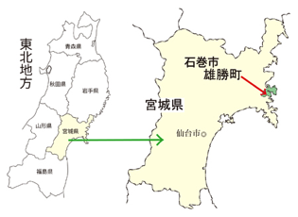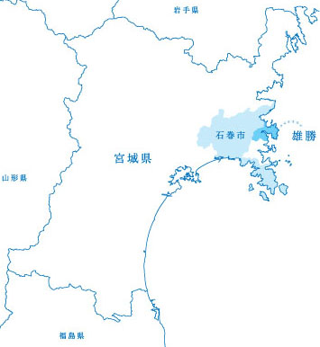

Figure 1. The Location of Ogatsu, in Ishinomaki City, Miyagi Prefecture

Left: <http://www.purple.dti.ne.jp/bunbutsu/osusume.html>

Right: http://ecomu.info/webticket_html/wt_ogatsu2014_main.html

## Ogatsu Peninsula

The Ogatsu Peninsula is in Miyagi Prefecture in Japanese northeast region of Tohoku (figure 1). Ogatsu is in the most souther part of the jagged saw-toothed rias coast, formed where rivers meet the sea in area with limited flat land between the ocean and nearby mountains. In the past, Ogatsu prospered though bonito fishing, deep sea fishing done using large fishing vessels. After changes in international fishing regulations, fishery industry in Ogatsu changed to the cultivation of fishery products in the 1970s, mainly scallops, sea squirts, and oysters. Ogatsu has the fortunate location in the southernmost part of Tohoku where the conditions are right for oyster cultivation; Ogatsu also produces the most scallops in all of Miyagi Prefecture. Ogatsu’s population has been declining since its peak of 11,214 in 1995, and before the GEJE, the population was 4,300.

## Regional Population Decline and Municipal Consolidation

Japan has a rapidly aging society, with one of the lowest birthrates in the world. Even before the GEJE, the tsunami-affected Tohoku region had an elderly population and rural depopulation occurring at an even faster rate than the national average, as younger residents moved away from rural coastal areas. In the past few decades, small towns with shrinking populations have been consolidated and merged together and into larger towns throughout Japan; the current outlines of most of the coastal towns affected by the GEJE are the result of a consolidation of multiple municipalities. As town planning for disaster recovery occurs under the authority of the local municipal government, this context of municipal consolidation makes recovery planning more complicated. In the case of Ogatsu, the formerly independent Ogatsu Town was incorporated into Ishinomaki City in 2005, along with several other nearby towns. After the GEJE, recovery planning for Ogatsu (now a District of Ishinomaki City) is carried out by the Ogatsu Branch Office of Ishinomaki City. The Ogatsu District includes 15 bays and fishing hamlets around the coast of the Ogatsu Peninsula, as shown in figure 2

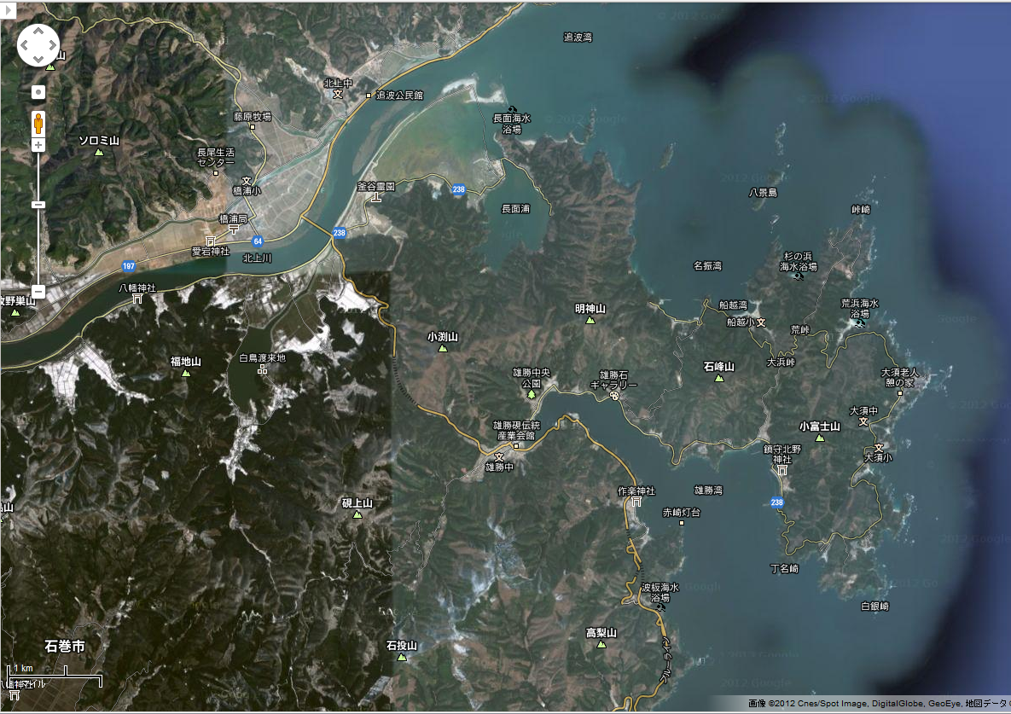

Figure 2. Map of fishing villages in Ogatsu Peninsula

# Recovery Planning after the GEJE

## Land Use Planning Guidelines in Tohoku

While acknowledging the limits of disaster prevention relying exclusively on physical infrastructure, recovery planning in the disaster area has tended to focus on physical disaster prevention strategies promoted by the national and prefectural governments, such as the construction of high seawalls and moving residents away from tsunami-inundated areas. One month after the disaster, the national government established the Reconstruction Design Council, who created a national recovery vision: “Toward Reconstruction: Hope beyond the Disaster” published in June 2011 (Reconstruction Design Council, 2011). The advisory guidelines included multiple land use strategies for the reconstruction of tsunami-affect areas in ways that would prevent future disaster damage, such as the relocation of residential areas to higher elevation, shown in figure 3.

Figure 3. Types of Relocation strategies included in the recovery vision.



Although these were only advisory, recovery plans of most municipalities followed these suggestions closely, including relocation to high land area (cutting mountain land to create a flat area), land raising, and multiple-defense strategies that combine levee construction, and land raising/relocation.

## National Support for Disaster Reconstruction Projects

In December 2011, the “Great East Japan Earthquake Special Area Law” was enacted and became the basis for allocating *kofunkin,* a type of government funding for recovery projects. In February 2012, the Reconstruction Design Council was succeeded by the National Reconstruction Agency, whose role is to coordinate the recovery budget and reconstruction process within various national ministries.

The Reconstruction Agency created the menu of 40 types of projects that were eligible for funding with *kofukin,* includingthe following reconstruction programs that have been widely adopted by municipalities throughout the disaster area in the recovery plans: collective relocation for disaster reduction program, land readjustment and raising programs, and the construction of public housing.

## Disaster Prevention Collective Relocation

### History of the Collective Relocation Project Policies

In Japan, the legal system that allows for the national government to fund residential relocation to prevent future disaster damage was created in the 1970s, and collective relocation has been part of post-disaster recovery in village reconstruction in the past, such as after the 2004 Chuetsu earthquake in Niigata Prefecture. After the GEJE earthquake, Collective Relocation for Disaster Prevention was designated as one of the reconstruction programs the national government would fund, and Collective Relocation for Disaster Prevention has been selected as the recovery project for many coastal areas and fishing villages, including the Ogatsu area. In the tsunami-stricken region of Tohoku, Collective Relocation for Disaster Prevention projects are planned for 335 areas, and as of March 2014 land preparation is underway in most of these areas, but only 8% were completed.1

### Collective Relocation Program Implementation

Collective Relocation for Disaster Prevention includes measures targeting both former residential areas and new residential land in less hazardous areas. Using this program, local governments designate the target area as a ‘hazardous area,’ where residential construction will be forbidden. Technically, this designation is based on the prediction of the future risk from natural disasters, but in practice as part of recovery, designated areas that have already suffered disaster damage. Residents have the option to sell their former land to the government and be compensated for it at a determined amount, based on a percentage of former land value, but residents are not required to sell and can chose to keep their land. As the other part of the Collective Relocation project, local governments provide new residential lots in safer areas, in the case of the GEJE these plots are at higher elevations. Residents from the disaster stricken areas have the option to buy or rent these lots new lots, and rebuild their own private houses on these lots.

### Disaster Recovery Public Housing in Relocation Areas

Local governments can also provide Disaster Recovery Public Housing, using a different project and reconstruction funding, for people who don't want to or are unable to rebuild their houses, especially the elderly. Many of the new relocation areas in created in the towns affected by the Great East Japan Earthquake include lots for private reconstruction along with public housing. Public housing includes large multifamily structures as well as single-family detached housing, which is most often used in small coastal towns and villages along with small scale relocation areas.

# Relocation Planning in Ogatsu

## Process of Selecting Disaster Prevention Collective Relocation for Ogatsu

Between the spring and summer of 2012, it was decided that the Disaster Prevention Collective Relocation would be carried out in Ogatsu, and residents were surveyed about their intentions to move to the new residential area in highland area. Of the 1150 eligible households who suffered damage, 280 (24.3%) declared their intention to join the relocation project. In a previous survey in 2011, 58.1% of residents had expressed the desire for a different (opposite) reconstruction strategy: elevated their lands and rebuilding on their own properties.

During the time when these decisions were being made, most Ogatsu residents were living in temporary housing outside their hometowns, as few temporary housing units had been constructed inside Ogatsu. Therefore, there were few opportunities for residents to meet and have a change to discuss their own plans and get information about other residents’ intentions to return. As discussions about other options instead of collective relocation, such as land raising and on-site rebuilding, were seen as delaying the process of deciding on the recovery process, it was difficult for residents who supported these options to suggest them. Instead of asking which type of reconstruction residents prefer (i.e. collective relocation or on site reconstruction), the only choices provided to residents was to join the collective relocation project, or not.

To implement a collective relocation project, the disaster-affected land area must be designated as a ‘hazardous area’ where building is forbidden; this is the logic behind the Disaster Prevention Collective Relocation measures. If the disaster-affected area is designated as one where on-site reconstruction is allowed (and therefore *not* designated as a ‘hazardous area’), it will become ineligible for collective relocation.

## Relocation plans for villages in Ogatsu

<figure 4. Relocation plans in Ogatsu>

## Issues for Long Term Recovery and Land Use

With a very small number temporary housing located in former areas, and with the difficulty of rebuilding on former land, the situation where very few people are living in the disaster area continues. As of May 2013, even if all the residents of Ogatsu who wanted collective relocation retuned to Ogatsu, there would only 35% of the pre-disaster population (1541 out of 4300 people). Losing the momentum for people to return to their region, and if this situation continues, and with the lack of chances to meet, based on the available information, people will decided not to return, and the number of people who move out will increase.

### Available land areas and long term land use planning

Through the designation of hazardous/no-build areas (required to use the Relocation for Disaster Reduction Project funding), the overall amount of land area available for housing construction is reduced and restricted. New land developed by the for residential relocation is limited to disaster survivors only, so in the future it would be difficult to build and new houses for newcomers, etc., so the future population will be limited to the number of households included in the current recovery plan. This will make town management more difficult and also restrict daily life, as facilities needed for residents daily life will be disappear along with a decreasing population.

### The example of Tachihama fishing village in Ogatsu

Tachihama is a fishing hamlet in Ogatsu, also shown in figure 2. In February 2011, before the GEJE, there were 49 households living in Tachihama, with a population of 160. Three years after the disaster, there are only 9 households, or 32 people, living in Tachihama. Of the 49 pre-disaster households, 19 plan to rebuild within Tachihama, and 30 households will move away.

　Two generations ago, fishermen from this area worked as employees on large fishing vessels, which was a dangerous job, but provided a comfortable pension. Because of the change in the fishing industry, these jobs and the accompanying pensions were not available for younger generations, who are involved in aquaculture, farming scallops, oysters, etc. The now-retired elderly generation of fishermen, are living comfortably on their large pension payments, and they can afford to rent private apartments or condominiums in urban areas.

Soon after the disaster, many fishermen moved out, thinking that it because of the heavy and huge amount of debris, it would not be possible to restart operations of the fishing port. On the other hand, there was also a group of younger fishermen who worked together, little by little to cleanup the harbor area, towards the goal of restarting the fishing operations. The result of this situation is that there has been a split between the older fisherman who have moved out, and the younger fishermen who are working to restart their work. For the residents who left, it may be difficult for them to return from the point of view of social pressure, since they have not been part of the process of cleanup.

## Examples of Self-built Housing

In the Ogatsu area, there are a few examples of residents who have started to rebuild houses on their own, without waiting for government support. In one case, a local man has started to clear the trees on his hillside land, as part of the process of building his own house with timber construction. There are also examples of people staying in more ad-hoc structures they have constructed by themselves, which are built to the standards of residential construction, but allow people to stay on their land, in their former villages.

# Conclusion

Without intervention, the implementation of official government reconstruction programs leads to people moving out of their hometown, and once they move out, it may become hard for them to return, for multiple reasons. To rebuild towns with a sustainable future, along with a recovery that supports the needs and desires of residents, recovery programs must provide more varied support, and initiatives that encourage residents to return, and varied ways that allow them to stay closer to the hometowns, including more flexible support such as self-built reconstruction.

In Ogatsu, the choice to use relocation for disaster prevention has lead to a recovery project that may not support residents’ abilities to return to their former towns, and will very likely contribute to increasing the number of residents who move away. Whereas the stated goal of the town reconstruction is to rebuild local areas, and support residents to live in their hometowns, the implementation of the recovery projects that support the varied needs and desires of residents, there should be additional options for varies support, or to provide housing support in more ways than through relocation.

# References

1. Recovery Agency (2014) available at: http://www.reconstruction.go.jp/topics/main-cat7/sub-cat7/1/20140310_sanko03.pdf

NPO machi-communication【Email】m-comi@bj.wakwak.com